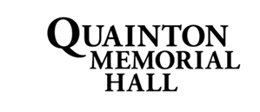
Investment Policy
Background
As a charity, QMH is not intended to be a profit-making organisation over the long term. Excess funds are built up so that future maintenance and replacement of assets can be funded.
General considerations
Security of capital is of paramount importance. Within that constraint, monetary assets are invested to aim for the maximum return available subject to practical limitations. A proportion of funds needs to be held in liquid form to cover short-term expenditure.
Detailed guidelines adopted
- Funds should be invested only with regulated institutions that are covered by the Financial Services Compensation Scheme. This ensures the security of capital.
- No less than £10,000 should be held in instant access accounts, to cover liquidity requirements.
- No more than £15,000 should be held in non-interest-bearing accounts in order to maximise investment return.
- Funds should not be tied up in notice accounts for more than 1 year.
- An annual review of rates earned should be carried out to ensure returns remain in line with the market.

Adopted on: 17 January 2017

Last reviewed: January 2024

Next review due: January 2025

