Poppy Appeal Lunch and Bingo – Saturday 10 November
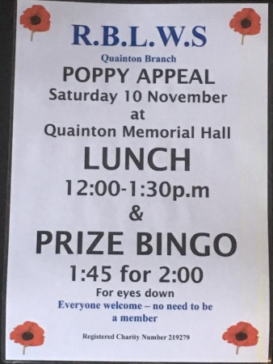
Wreath ceremony, WW1 history display and refreshments in Quainton Memorial Hall on Remembrance Sunday, 11 November 2018.
On Sunday 11 November, a procession will leave from the Remembrance Service in the Parish Church of Holy Cross and St Mary and make its way to Quainton Memorial Hall where a wreath will be laid. Refreshments will be available from 4.30pm in the Hall. There will be a display in the hall about the history of those on the WW1 war memorial and the “Lest we Forget” bottles of commemorative ale will be available for a donation.
Villagers will leave from the hall for The Beacon Lighting on Mill Hill at 6.45pm.
The photos show the memorials for Quainton men who died in the two World Wars which are displayed in Quainton Memorial Hall.
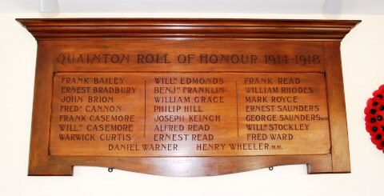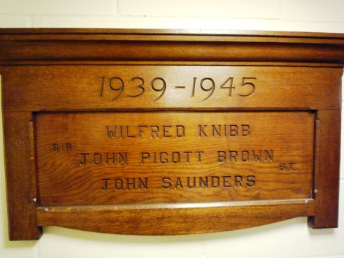

Silent Silhouette
When it looked as if Quainton might not get a soldier silhouette to commemorate the end of the First World War, two creative villagers made one for us. It is amazing. Huge thanks go to Jan and Bernard for making it. It is currently in the entrance to Quainton Memorial Hall

